1. Executive Summary:
   * Scooby-Doo is an adventure game made available on PS, XBOX, and PC. This game will dominate your nostalgia as you emerge yourself and a friend into the Scooby-Doo Universe like never before. Using top notch meddling skills, the player will play as each member of the gang, solving mysteries from the past, present, and future; from Coolsville to all around the world.
2. Audience Analysis:
   * This game targets children from ages 6-11 years.
3. Story:

Geist

The “Geist” of the game is to work together with the other members of the Scooby Gang to solve mysteries and puzzles using skills such as:

* Meddling
* Puzzle solving
* Problem solving
* Critical thinking.
* Attention to details.
* Coding and technology knowledge

In order to unlock a broader field of mysteries that expand to all around the world and even through time and space.

Summary

The story begins with the very mystery that started it all, “What a night for a Knight.” This is a tutorial mystery, led by The Boo Brothers. This guides the player through all the playable elements that will be used throughout the game. The Boo Brother’s will be accessible throughout the game as needed.

|  |  |  |
| --- | --- | --- |
| “What a Night for a Knight” | | |
| * Collected all Scooby Snacks | * Coolsville Map | * Automotive Parts |
| * Kitchen Key | * Website IP for VLOG | * Black Credit Card for Daphne’s Closet. |

Each mystery will have a different story premise, but it will carry out the same basic gaming elements, which will be later explained. Once the mystery is solved, the player will be notified of their achievements, what they unlocked, and trophies. Example:

Solving the mystery:

* The player will search rooms by walking up to playable objects and examine.
* Each clue is a puzzle.
* The player needs to collect five trap pieces and clues.
* After collecting everything the player will help Freddy set up the trap and become the bait luring the ghost.
* Unmasking-the player will be guided through the clues to guess the culprit. The player will get three tries to guess, if unsuccessful they must restart the mystery.

After solving, “What a Night for a Knight,” the gang meets up at the molt shop.

* Character selection.
* Access to the mini games.
* Locate new mysteries by:
  + Molt shop’s bulletin board.
  + Newspaper.
  + Walking and driving around Coolsville, which will be accessible by approaching a Scooby-Doo Dog Tag hovering in front of locations in the game.
* Split screen option.
* Each mystery unlocks elements in the game:
  + Playable characters.
  + Mini games.
  + Mysteries:
    - Specified mysteries move the game forward such as:
      * Once the mysteries in Coolsville are solved, the game expands to Crystal Cove.
      * Another mystery at a Science University will unlock an accidental trip to the past.
      * The last mystery to solve in Crystal Cove at an airstrip, unlocks mysteries they can solve all around the world.
* Celebrity NPCs-Along the way, the gang meets some old friends and makes a lot of new ones as they make a name for themselves as the teenage mystery solving sleuths.

**Mini Game Summary**:

Each character has their own mini game, which ties into the character dynamics in the story of the game and provides customization to both the characters and the Mystery Machine.

Daphne – Dive into the fashion icon that Daphne Blake is with access to her vast closet. In this unlockable mini game, the player can select a variety of outfits designed for not only Daphne, but for all members of the Scooby Gang.

Velma – Surround yourself in the world of mysteries while you pick Velma’s keen brain in her virtual VLOG. In this mini game, the players can connect with other players via online for help or social chat. There are also puzzles you can solve that hone-in on basic coding. Throughout the story, NPCs will post on Velma’s VLOG requesting the Scooby gang’s help. This is where the players can solve mysteries for payment to advance in other parts of the game.

Fred – Freddie’s love for his mystery machine is even more than his love for setting traps. Collect **Automotive Parts** throughout the game to be able to work on and trick out the Mystery Machine. From custom paint jobs, to added on body parts, to engine enhancements, and specialized tapping mechanisms.

Shaggy & Scooby: Welcome to Shaggy’s kitchen. The player will collect ingredients throughout the game and come back to Shaggy’s kitchen to make top notch world renown recipes along with some of Shaggy and Scooby specialties they have made over the years.

Two other mini games will be unlocked after solving mysteries:

Laff-a-lympics: Players start your engines! Test you luck, skills, and patience as you select your driver and team. Choose from the Scooby Doobies, the Yogi Yahooeys or the Really Rottens. Each player has their own tricks and toys up their sleeves to race their way to the finish line. In this mini-driving game you will have access to two types of races. Once single race around the racetrack or play in a tournament in four tracks around Race Mountain.

Wrestling/Training: Players will be able to train as Dead Meat and Scooby to learn and practice acrobatic moves and combos they could use in the game to fight off ghosts. Face off in the ring with WWE wrestlers and DIVAs to be titled the WWE Champion.

1. Competition Analysis:

|  |  |  |  |  |  |  |  |  |  |  |  |  |  |
| --- | --- | --- | --- | --- | --- | --- | --- | --- | --- | --- | --- | --- | --- |
| TITLE | ADVENTURE | PUZZLE SOLVING | SPLIT SCREEN | | | INTERACTIVE ENVIRNMENT/EXPLORATION | SPECIAL GUEST NPCs | | MINI GAMES | | | INTERCHANGABLE CHARACTERS | QUICK TIME EVENT (QTE) |
| SCOOBY-DOO | X | X | | X | X | | | X | | X | X | | X |
| KINGDOM HEARTS |  |  | |  |  | | | X | | X | X | |  |
| UNCHARTED DRAKES FORTUNE | X | X | |  | X | | |  | |  | X | | X |
| TOMB RAIDER (2013) | X | X | |  | X | | |  | |  |  | | X |
| LIFE IS STRANGE | X | X | |  | X | | |  | |  |  | |  |

* + Competition to popular games:
  + Comparison to other Popular Scooby-doo counsel video games:

|  |  |  |  |  |  |  |
| --- | --- | --- | --- | --- | --- | --- |
| TITLE | SYSTEM (C,PC,) | SPLIT SCREEN | INTERACTIVE ENVIRNMENT/EXPLORATION | DRIVEABLE MYSTERY MACHINE | MINI GAMES/PUZZLES | INTERCHANGABLE CHARACTERS |
| SCOOBY-DOO | C,PC | X | X | X | X | X |
| Scooby-Doo! First Frights (2018) | C | X |  |  |  | X |
| SCOOBY-DOO! AND THE SPOOKY SWAMP (2010) | C |  |  |  | X | X |
| [Scooby-Doo! Mystery Mayhem](https://scoobydoo.fandom.com/wiki/Scooby-Doo!_Mystery_Mayhem) - 2004 | C |  |  |  |  | X |
| Scooby-Doo! Case File - 2002 | PC |  |  |  | X |  |
| [Scooby-Doo! Night of 100 Frights](https://scoobydoo.fandom.com/wiki/Scooby-Doo!_Night_of_100_Frights) - 2002 | C |  |  |  |  | X |

1. Marketing:

I predict that SCOOBY DOO will be a success in the years to come. SCOOBY DOO will fulfill all the player’s current desires such as: ONLINE SOCIAL CHATS, SPLIT SCREEN, PUZZLES. See the below statistics on the Titles from the above table “Competition Analysis.”

|  |  |
| --- | --- |
| TITLE | SALES |
| SCOOBY-DOO | Est. 7 million |
| KINGDOM HEARTS | 6 million |
| [UNCHARTED: DRAKE’S FORTUNE](https://en.wikipedia.org/wiki/Uncharted:_Drake%27s_Fortune) | 4.8 million |
| TOMB RAIDER (2013) | 8.5 million |
| LIFE IS STRANGE | 3 million |

1. Game Mechanisms: Platforms (PS, Xbox, & PC)



There will be many different elements used in this SCOOBY-DOO game. All elements current players know well. See below:

* + Search for clues:
    1. Examine things around the room by pressing triangle when prompted.
       1. I.E. Books. Drawers. Computers. Surfaces. Footprints.
    2. Once the clue is found, use the tools to investigate:
       1. Fingerprint with Daphne's blush.
       2. Velma's magnifying glass.
       3. UV light, flashlight.
  + Scooby snacks:
    1. Simply walk over the Scooby Snack and collect them. Tally numbers shows how much to collect.
    2. Smash crates get Scooby Snack Boxes.
  + Run away:
    1. Camera faces Character and NPC Ghost, dodge unseen obstacles.
    2. QTE-press prompted buttons to dodge ghost's attempts to get you.
  + Trap pieces:
    1. Solve puzzles to get trap pieces.
    2. Crack open locked areas: I.E. chests, closets, under beds, lockers, ect.
  + Automotive parts:
    1. Awarded when the player solves the mysteries.
    2. Use money earned for solving mysteries to buy parts.
  + Climb/scale:
    1. Hold O button next to an area that you can climb and use directional buttons to scale around area. Path is a noticeably slightly different texture.
  + Swim/Driving/Piloting:
    1. Press X button to dive underwater, use directional buttons to navigate in the water. Air does not deplete.
    2. Hold X to go. O to reverse. Direction keypad to direct.
  + Dodge:
    1. QTE prompted buttons.
  + Types of puzzles:
    1. Hidden Objects.
    2. Actual puzzle.
    3. Mother board circuits.
    4. Coding.
    5. Hieroglyphics-Velma’s brief history on mystery.
    6. Word Play.
  + Trap Setting:
    1. Five objects needed – once all objects are collected….

1

7

6

5

4

3

2

8

9

10

1. Directional.
2. Share.
3. 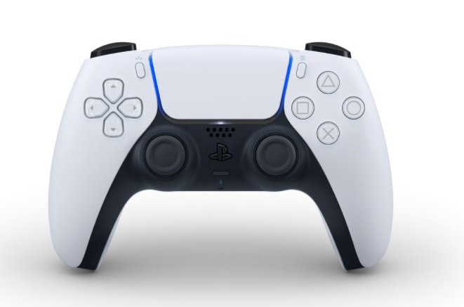Map short cut.
4. Pause Menu:
   * Save, load, quit, button, inventory, map, ect.
5. Interact=(Talk/Examine).
6. Special Item – What is selected from #9. (I.E. Inventory Items.)
7. Specialty Moves-Combo/Acrobatics.
8. Jump. Double press to jump higher. Press up button to pull up from ledge.
9. Camera Angle.
   * Hold up to select items to use for #6 button.
10. Directional. Press/hold down to creep(stealth)
11. L1-Asking the Boo Brother’s for help.
    * The screen appears black and white, and The Boo Brothers appear with easy riddles/guides player to next clue.
12. Backpack Menu:
    * Scooby snacks

**11**

**14**

**13**

**12**

* + 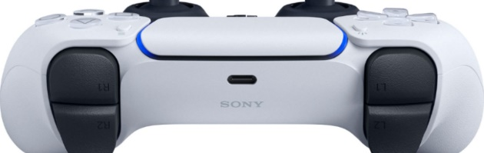What has been collected  
    throughout mystery.
  + Checklist for mystery.

1. Crouch-Press / Hide-Hold.
2. Run fast-hold and use directional button.
3. Budget & Schedule:

|  |  |  |  |
| --- | --- | --- | --- |
| TITLE | SCHEDULE | BUDGET | STAFF SIZE |
| SCOOBY-DOO | EST. 4 YEARS | EST. $20-30 million | EST. 30 |
| KINGDOM HEARTS 3 | 6 YEARS | $50-$150 million | Unknown |
| UNCHARTED: DRAKE’S FORTUNE | 3 YEARS | $20 million | Unknown |
| TOMB RAIDER (2013) | 5 YEARS | $100 million | Unknown |
| LIFE IS STRANGE | 3 YEARS | $6-7 million | 15 |

**DESIGN DEPARTMENT**

GAME DESIGNER

STORY DESIGNER

LEVEL DESIGNER

**PRODUCTION DEPARTMENT**

CONTENT DEPARTMENT

CONCEPT ARTIST (2D)

TEXTURE ARTIST

3D ARTIST

3D ANIMATOR

SOUND ENGINEER

MUSIC ENGINEER/COMPOSER

DELEVOPMENT DEPARTMENT

GAME DEVELOPMENT

RENDER ENGINEER

**RELEASE & MANAGEMENT DEPARTMENT**

PROJECT MANAGER

QA ENGINEER